NOTICE OF PUBLIC HEARING
December 5th, 2019 at 7:00 p.m.
There will be a Public Hearing on Thursday, December 5th, 2019, starting at 7:00 p.m. in the Shaw Auditorium at the Vancouver Island Conference Centre at 80 Commercial Street, Nanaimo, BC, to consider a proposed amendment to the “City of Nanaimo Zoning Bylaw 2011 No. 4500”.

All persons who believe their interest in property is affected by the proposed bylaw will be given the opportunity to be heard in person, by a representative, or by written submission, on the matters contained within Amendment Bylaw No. 4500.164 at the Public Hearing.
Map A
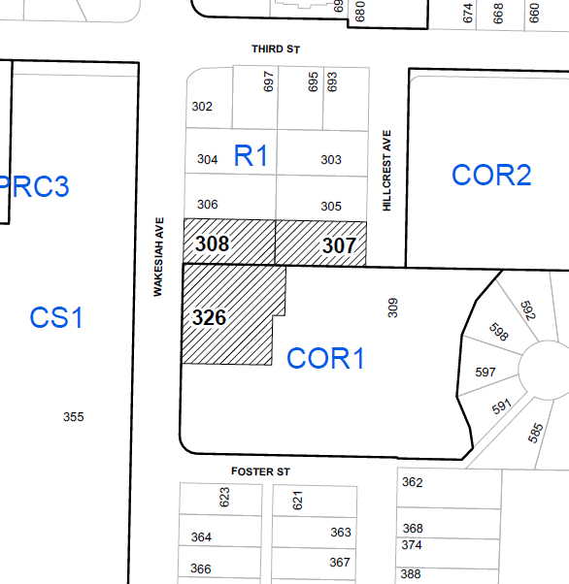
BYLAW NO. 4500.164
Location: | 307 Hillcrest Ave; 308 and 326 Wakesiah Avenue  as shown on Map A
File No.: | Rezoning Application – RA000398
This bylaw, if adopted, will amend the existing zoning from Single Residential Dwelling (R1) and Residential Corridor (COR1) to Mixed Use Corridor (COR2) in order to allow a mixed-use student housing development.

The subject properties are legally described as:

LOT 10, SECTION 1, NANAIMO DISTRICT, PLAN 18677; LOT 1, SECTION 1, RANGE 5, NANAIMO DISTRICT, PLAN 28419; LOT 1, SECTION 1, RANGE 5, NANAIMO DISTRICT, PLAN 28419
N

Subject properties
WANT TO FIND OUT MORE INFORMATION?

IN PERSON: A copy of the above-noted bylaw and related documents may be inspected from November 22nd, 2019 to December 5th, 2019, from 8:00 a.m. to 4:30 p.m., Monday through Friday (excluding statutory holidays), at the City of Nanaimo, Development Services Department front counter in the Service and Resource Centre, located at 411 Dunsmuir Street.
WEBSITE: What’s Building In My Neighbourhood?
Access rezoning and application information on the City’s webpage by typing in the relevant civic address or file number at: www.nanaimo.ca/whatsbuilding.

WANT TO MAKE A WRITTEN SUBMISSION?
If you are unable to attend the Public Hearing, written submissions must be received no later than 4:00 p.m., December 5th, 2019, to ensure their availability to Council at the Public Hearing. Written submissions can be provided by any of the following methods:
IN PERSON: Drop off at the Service and Resource Centre, located at 411 Dunsmuir Street
BY EMAIL: public.hearing@nanaimo.ca
WEBSITE: Submit comments directly through the City’s website at www.nanaimo.ca/publichearing
MAIL TO: City of Nanaimo, Development Services Department, 455 Wallace Street, Nanaimo, BC, V9R 5J6

If you would like more information about Public Hearings please go to the City website at www.nanaimo.ca and use the search function to find the ‘Public Hearing Information Sheet’, which contains many frequently asked questions.

If you would like more information about Public Hearings please go to the City website at www.nanaimo.ca and use the search function to find the ‘Public Hearing Information Sheet’, which contains many frequently asked questions.

Following the close of a Public Hearing, no further submissions or comments from the public or interested persons can be accepted by members of City Council, as established by provincial case law. This is necessary to ensure a fair Public Hearing process and provide a reasonable opportunity for people to respond.

This Notice is published in accordance with Section 466 of the Local Government Act.
Notice given by the Corporate Officer.

City of Nanaimo – Development Services Department, Service and Resource Centre
411 Dunsmuir Street www.nanaimo.ca
Phone: (250) 755-4429 Fax: (250) 755-4439

